Changes to the diagram

Context

This document explains the changes that have been made from version 2 diagrams to version 3 diagrams.

# User UML-Class Diagram

# 

***Fig 1: UML-Class Diagram from a user version 2***

***

***Fig 2: UML-Class Diagram from a user version 3***

**Changes**

**From the above diagrams we can see that the class and variable “purpose” in version 3 has been removed. Purpose indicated the relation between the request made from one user to a next. For the reason that a role of a user already indicates their purpose in the system in using the “purpose” class and variable of no use.**

# Patient UML-Class Diagram

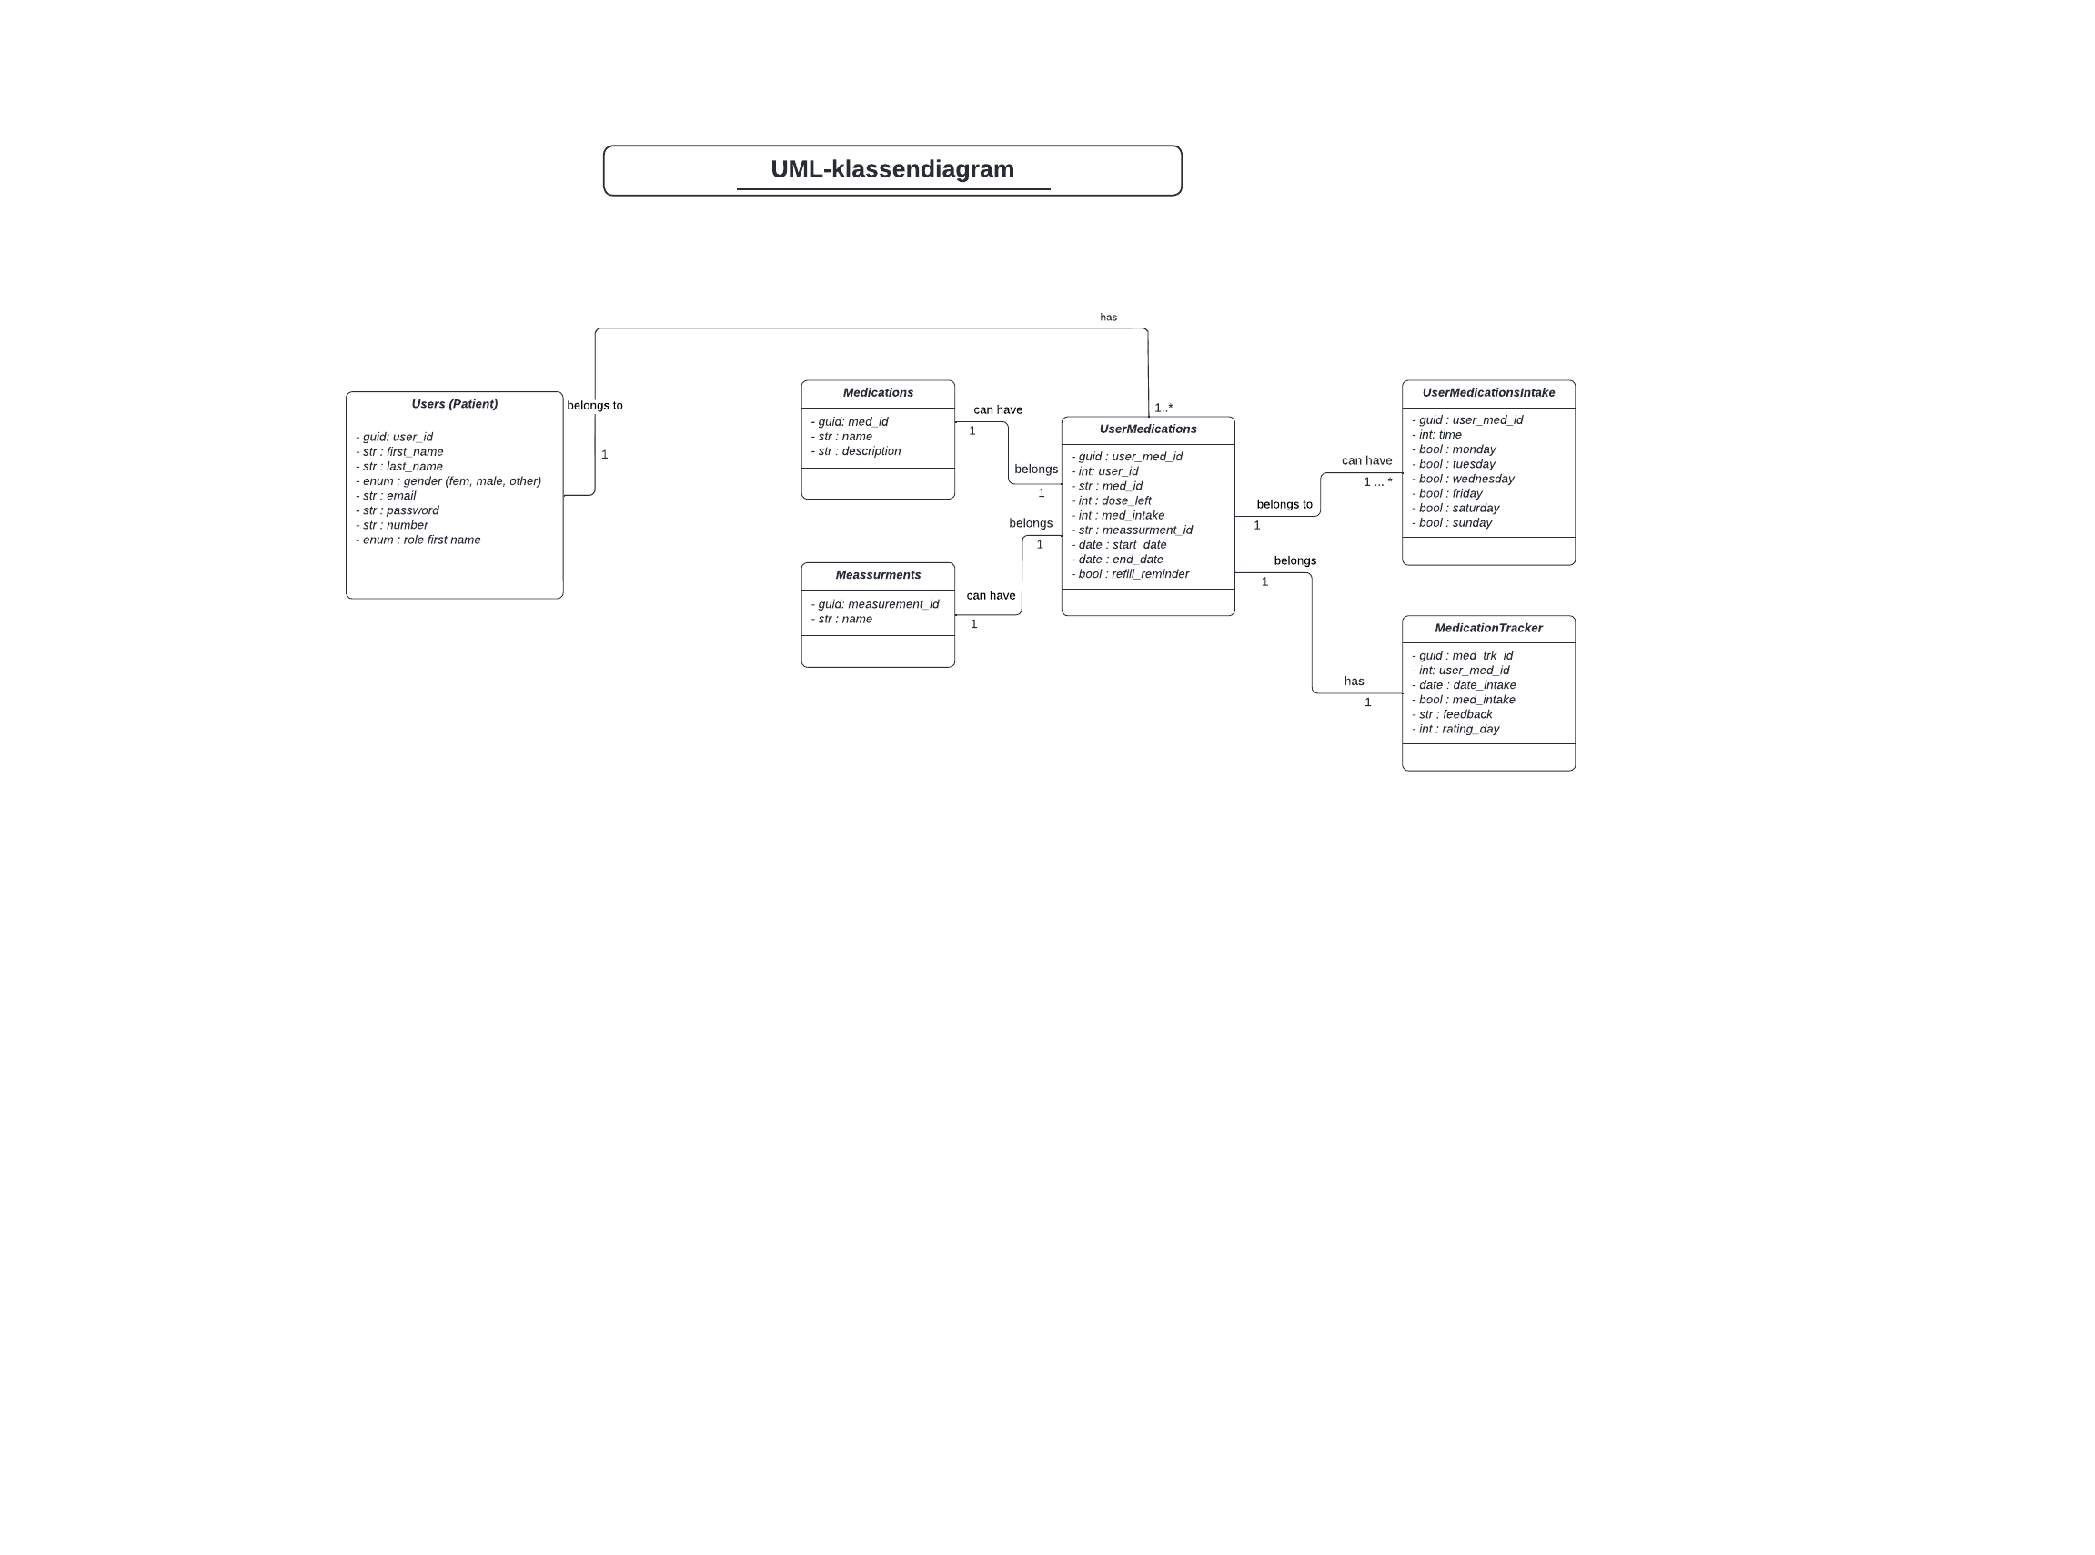

***Fig 3: UML-Class Diagram from a patient version 2***

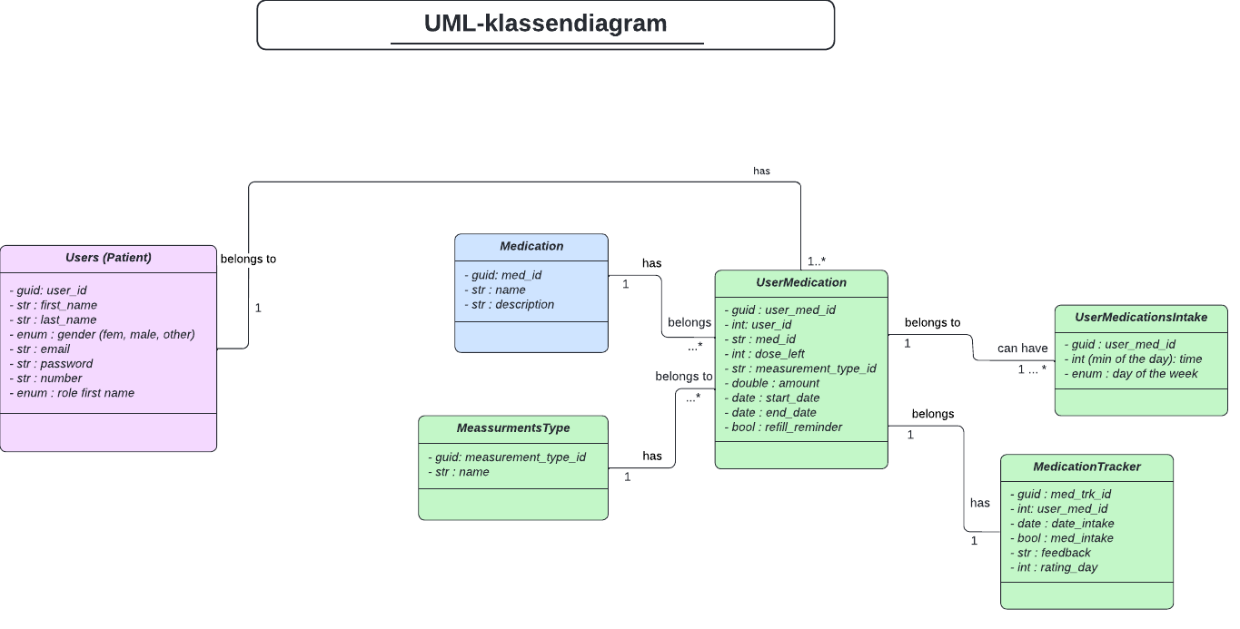

***Fig 4: UML-Class Diagram from a patient version 3***

**Changes**